Colorful Choices Challenge - Department Email Templates

Email #1 Send: Week of November 2, 2026
Subject: Eat Colorfully. Earn Points. Have Fun! Join Colorful Choices

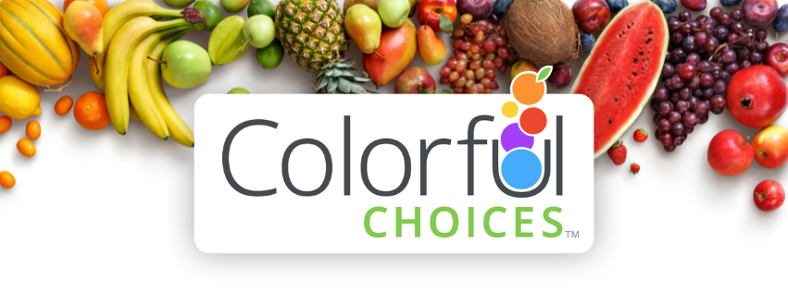

Dear Colleagues,

Get ready for Colorful Choices, the Citywide healthy eating challenge!

This fun 4-week challenge encourages you to add more colorful fruits and vegetables to your day and discover simple ways to build healthy eating habits.

Registration opened Monday, October 26, 2026
Challenge runs from November 16 – December 13, 2026

With Colorful Choices, there’s no calorie counting, weighing, or measuring. Simply log your fruit and vegetable servings to earn points throughout the challenge.

Here’s what you can look forward to:
- Earn points for eating fruits and vegetables
- Discover healthy eating tips and recipes
- Track your progress online or with the mobile app (Apple and Google Play)
- Connect and share encouragement on the Wellness Wall
- Earn chances to win individual or team raffle prizes

Make it More Fun with a Team
Participate on your own or start or join a team of 4–8 coworkers and friends. If you create a team, be sure to include our department’s 3-letter department code in your team name.

Ready to make your plate more colorful? Register today at sfhss.colorfulchoices.com/welcome.

Thank you,
[ADD Champion Name(s)]

Email #2 Send: Week of November 16, 2026
Subject: Colorful Choices Challenge Starts November 16!

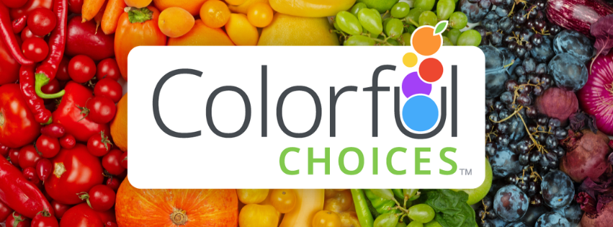

Dear Colleagues,

Colorful Choices started this week! There’s still time to register and get ready for the 4-week Citywide healthy eating challenge.

During the busy holiday season, Colorful Choices can help you find simple ways to add more fruits and vegetables to your day while still enjoying your favorite seasonal foods.

The goal is simple: add a colorful variety of fruits and vegetables to your day and build healthy eating habits along the way.

How It Works
From November 16 to December 13, 2026, log your fruit and vegetable servings each day and aim for a variety of 5 colors: red, orange, yellow/white, green, and blue/violet.

As you log, you’ll earn points and work toward your challenge goal:
- Vegetables: 20 points per serving
- Fruits: 10 points per serving
- Top Choices: Earn 10 bonus points
- Reach 60 points in a day to earn a sticker
- Aim for 16 stickers during the 28-day challenge to meet the overall program goal

Make it More Fun with a Team
Participate on your own or start or join a team of 4–8 coworkers and friends. Log your produce, complete weekly Team Activities, and move up the Team Leaderboard together. If you create a team, be sure to include our department’s 3-letter department code in your team’s name.

Take Colorful Choices with you
Download the mobile app to log your fruits and veggies anytime, anywhere, track your progress, find healthy recipes, and connect with others on the Wellness Wall.

Earn Chances to Win Raffle Prizes
There are several ways to earn raffle entries throughout the Colorful Choices Challenge:
- Register by November 16
- Join a team by November 27
- Log your fruits and vegetables at least 4 days each week
- Meet the overall challenge goal of 16 stickers
- Complete the end-of-program evaluation

Not registered yet? There’s still time! Register at sfhss.colorfulchoices.com/welcome.

Thank you,
[ADD Champion Name(s)]

