Department Emails

Key Players:
Please use the provided email templates to communicate with your department and help promote the Good Nurtured Challenge. You're welcome to edit and customize the content as needed to best fit your audience.

Email #1 – Send the week of June 23
Subject Line: Citywide Challenge, Good Nurtured, Registration Now Open!
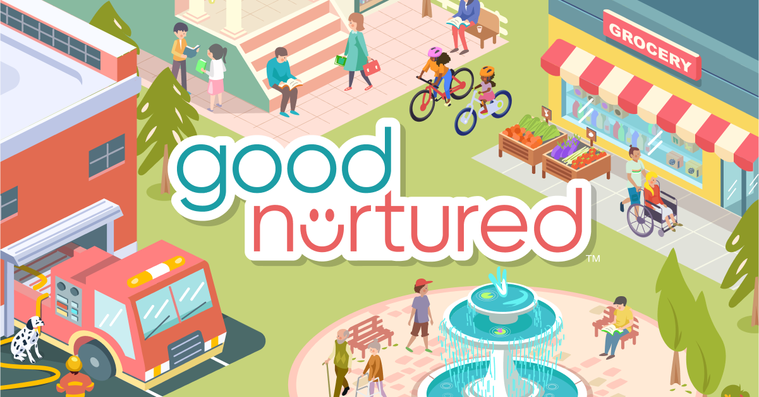

Hello Colleagues,

Sign up and join the citywide Good Nurtured Challenge. In this 4-week well-being challenge, you’ll use a virtual platform to learn and do “Good Things” — Good things that not only nurture goodness, but boost happiness and improve health.

What is the Good Nurtured Challenge?
This challenge is designed to raise awareness of the mental, emotional, and physical health benefits of kindness and graciousness. The goal is to inspire you to:
- Spread kindness
- Strengthen connections
- Build lasting well-being habits

During the challenge, you will explore the 3 Good Things categories:
- Good to Me are physical, emotional, and social self-care practices.
- Good to You are kindness, graciousness, and civility toward people you know.
- Good to All are acts of goodwill toward people you don’t know. Your goal is to record 10 Good Things each week on the platform (with the option to earn up to 21) to reveal a creative, animated scene.

Why Join?
This challenge not only fosters personal well-being but also cultivates a positive workplace culture characterized by improved collaboration, communication, and overall job satisfaction. By participating, you may experience:
- Reduced stress
- Increased optimism
- Greater resilience
- Increased happiness
- Stronger social connections

Challenge dates: Monday, July 14 through Sunday, August 10

Tips to help you get started:
Step 1: Register and create an account on the web version
Step 2: Download the free Good Nurtured mobile app
Step 3: Start tracking your “Good Things” on July 14

Use the Friends feature, invite 1 or more to join you; add to the fun and increase your chance of success and take advantage of other motivating features such as Good Notes, Achievements, Badges, and the Community page.

Ways to Win Raffle Prizes
- Register before July 14
- Add at least one friend
- Track your progress 5 days each week throughout the challenge
- Reach the program goal of 40 Good Things by the end of the challenge
- Complete the evaluation survey

Register today at sfhss.goodnurturedchallenge.com.

Thank you,
[Champion Name(s)]

Email #2 – Send the week of July 7
Subject Line: Join the 4-Week Good Nurtured Well-Being Challenge – Starting July 14!

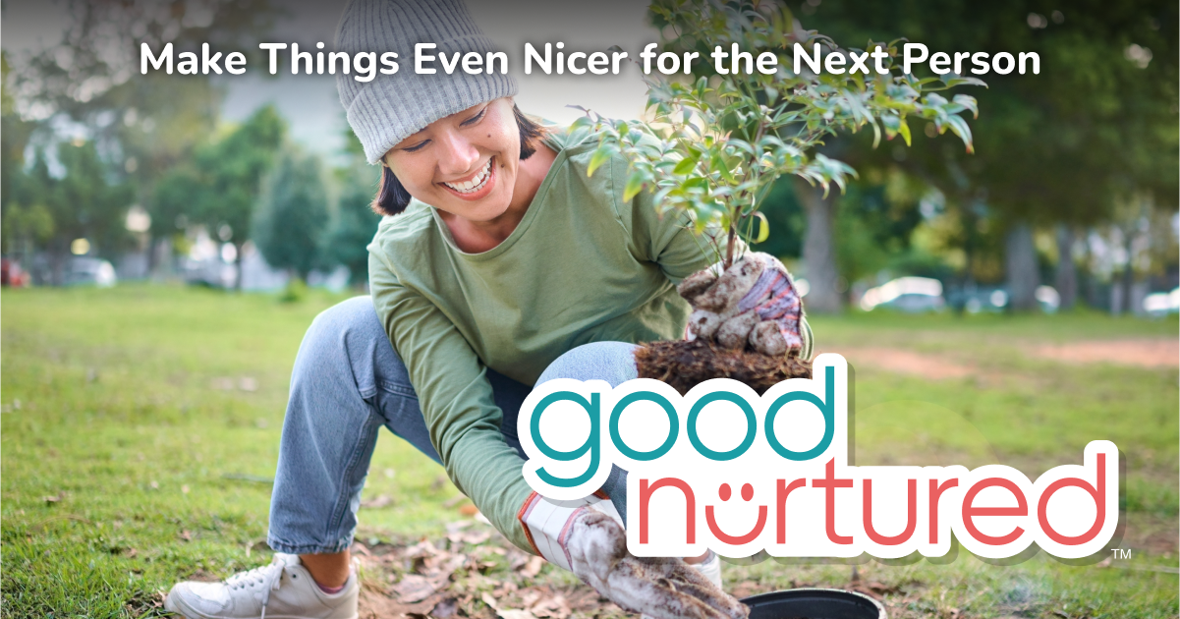

Hello Colleagues,

We’re excited to invite you to participate in the citywide challenge, Good Nurtured, a 4-week journey to enhance your well-being through simple, meaningful daily actions.
Challenge begins Monday, July 14 – Register Today!
Register here - sfhss.goodnurturedchallenge.com

What is the Good Nurtured Challenge?
This challenge is designed to raise awareness of the mental, emotional, and physical health benefits of kindness, and graciousness. The goal is to inspire you to:
- Spread kindness
- Strengthen connections
- Build lasting well-being habits

Why Join?
By participating, you may experience:
- Reduced stress
- Increased optimism
- Greater resilience
- Increased happiness
- Stronger social connections

Build Your Daily “Good Things” Habits
You’ll be encouraged to complete simple well-being actions each day in three categories:
- Good to Me: Acts of self-care — physical, emotional, and social
- Good to You: Kindness and civility toward people you know
- Good to All: Goodwill extended to those you don’t know

5 Ways to Win!
- Register before July 14
- Add at least one friend
- Track your progress 5 days each week throughout the challenge
- Reach the program goal of 40 Good Things by the end of the challenge
- Complete the evaluation survey

Make It Easy with the Good Nurtured App
Track your activities, get daily tips, see your friends’ progress, and share wins — all from the palm of your hand. Scan the QR code below to download the app after you register:


Let’s nurture a culture of kindness — together!

Warmly,
[Champion Name(s)]

