Use these email templates to help promote the Live, Feel, and Be Better Campaign in the new year. Content highlighted in yellow must be updated. Please feel free to tailor the language to fit your audience.

Email #1 – Send Week of 1/2

Subject line: Live, Feel, and Be Better in 2023

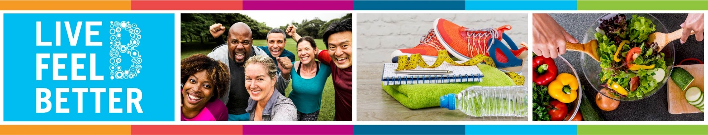

Build Healthy Habits that Matter

Live, Feel, Be Better in 2023 and focus your attention where you need it the most.

This year, I plan to focus on ___. (Insert a line about your personal goal for 2023)

Focus on What Matters Most to You:
- Get Started: Take an assessment through your health provider or meeting with your physical to get your annual physical exam
- Set a Goal: Get a healthy start to your year by creating a SMART goal.
- Get Support: Access support through your SFHSS benefits. Join a program and tap into your health plan for additional support.

Learn More at sfhss.org/lfbb2023

Email #2 – Send Week of 1/16

Subject line: Set a Goal for 2023

Set a Goal that Matters to You

Live, Feel, Be Better in 2023. Find comfort in a new healthy routine by setting a SMART goal.

Get support setting your goals:
- Take an assessment through your health provider or meet with your physician to get your annual physical exam.
- The key to a healthy start is creating a SMART goal that can help keep you accountable. Download our SMART Goal Worksheet to develop a goal that works for you.
- Meet with a Lifestyle Coach for one-on-one support on goal setting. Schedule a 20-minute appointment to learn about tips and tools to help get you started on your goal.

Lifestyle Coach appointments are virtual and will provide you with an opportunity to discuss challenges and opportunities to stay motivated with your goal.

Tap Into Your Health Plan:
Visit the Using Your Benefits Page to learn more about how your health plan can provide support in your well-being goal.

Learn More at sfhss.org/lfbb2023

Email #3 – Send Week of 1/30

Subject line: Prioritize Your Health

Live, Feel, Be Better in 2023. Explore resources that can set you up for success. It's not too late to get started and take an assessment or meet with your physician to get your annual wellness check-up.

Get Support with Your Goals
Engage in a program to help you focus on what matters most to you in 2023.
- Healthy Habits Program - Join this 6-week program led by a Wellness Coach. Participants will create realistic and sustainable goals and learn how to stay motivated in maintaining healthy habits all year long. Program starts in February. Register Today!
- Employee Assistance Program - services are available if you need extra support and can help connect you to helpful resources.
- Check out your Heath Plan Benefits - SFHSS health plans provide programs and well-being offerings. Find a program that works best for you! Visit Using Your Benefits to learn more about your benefits!

Here are some additional resources to support your goals: (Insert Information about resources relevant/meaningful to department—online GEX classes, seminars, stretch breaks, or online websites to help support well-being goals)

Learn More at sfhss.org/lfbb2023

