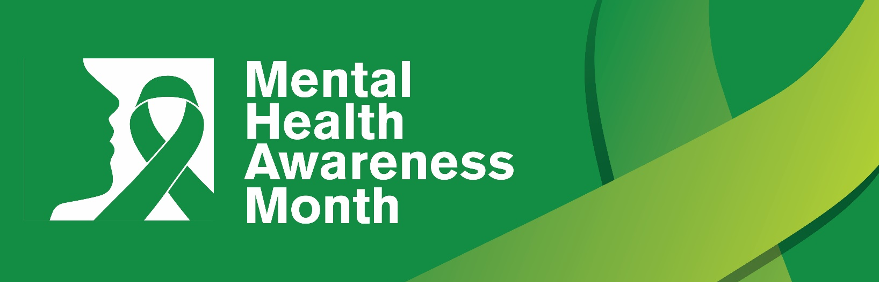
Dear Colleagues,
There has been a dramatic shift over the past four years in the state of workplace mental health, which has only been accelerated by a global pandemic, racial justice, and workplace stress and burnout. Work is one of the leading causes of stress for adults in the United States and job-related stress is linked to poor mental health. When stress is not managed, it can pose serious concerns for your physical and mental health and lead to burnout. Headspace’s 2024 Workforce State of Mind Report, 77% of employees say that work stress has negatively impacted their health. Work stress is often unavoidable, but we can learn healthy ways to manage our stress and mental health at work.
During Mental Health Awareness Month this May, SFHSS supports this national movement by reducing stigma, educating our members, and providing support.
Your mental health journey starts with a single moment, so Don’t Wait—Reach Out for help. It’s okay to ask for help. Hear from our city leaders on where you can get started. No matter where you are on your mental health journey, we encourage you to seek out many of the free tools and resources available to support your mental health and well-being. Call (628) 652-4600 or visit, sfhss.org/were-here-for-you for more information.
[Embedded video and link to: https://www.youtube.com/watch?v=zqU7GARU8bk]
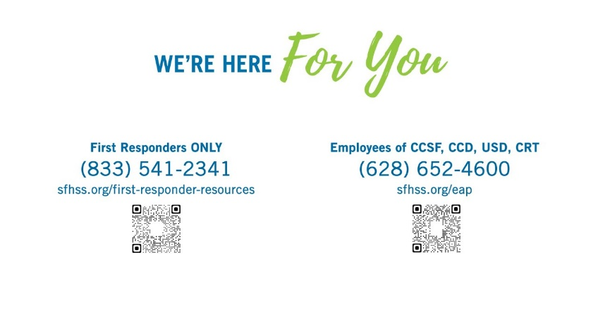
Thank you,

