**Department Email Template**

**Send Date:** Wednesday, May 7

**Email Subject:** Fostering a Respectful and Supportive Workplace

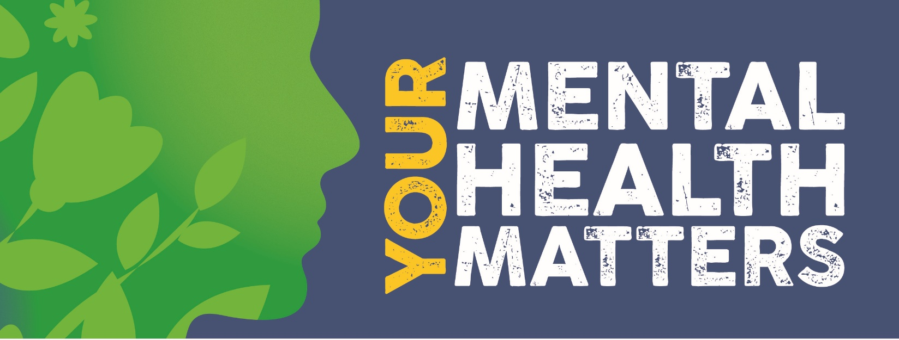

Dear Colleagues,

The City and County of San Francisco is committed to creating a safe, healthy, and respectful workplace for all employees. This includes ensuring that every individual is treated with civility and dignity, free from disrespectful behavior. It is essential that we maintain a respectful, professional, and supportive work environment for everyone. Civility not only boosts morale but also creates a positive workplace culture and enhances productivity, collaboration, and overall well-being.

This May, in recognition of Mental Health Awareness Month and in partnership with SFHSS, [INSERT Department Name] is proud to support this important movement by reducing stigma, offering education, and providing valuable resources to employees. If you don’t know where to start, take an [online assessment](https://sfhss.crediblemind.com/assessments/whats-your-mental-health-profile/page1) or reach out to the [Employee Assistance Program](https://sfhss.org/eap) by calling **(628) 652-4600.** Remember, seeking help is a sign of strength, not weakness, and you are never alone.

Explore and share helpful resources designed to support you on your mental health journey.

**Get Started Today:**

1. Download the events [**calendar**](https://sfhss.org/resource/mental-health-awareness-month-event-calendar-2025)  and join the sessions that you feel most helpful to your mental health.
2. [**Take a self-assessment**](https://sfhss.crediblemind.com/assessments/whats-your-mental-health-profile/page1) to better understand your well-being and start exploring the available resources.
3. Show your support and join the [**Be Seen in Green**](https://sfhss.org/event/well-being-programs-events/mental-health-awareness-be-seen-green-challenge) challenge
4. [**Learn about the Power of Meditation**](https://sfhss.org/event/webinars/power-meditation) and put it into a [**weekly practice**](https://sfhss.org/event/exercise-classes/meditation-series-putting-it-practice) to support daily mental clarity and balance.
5. [**Register and get trained**](https://forms.office.com/g/nb2U0Yrm1H) in mental health first aid in the workplace. Learn how to recognize, and reduce stigma, support colleagues who may be experiencing a non-crisis mental health or substance use challenge.

Let’s work together to make our workplace a safe, respectful, and supportive environment. Thank you for your ongoing dedication and commitment to fostering a positive and inclusive culture. Together, we can build a workplace where everyone feels valued and respected.

Warm regards,

[INSERT Signature]**­­**