Department Email Template
Send Date: Week of April 27
Email Subject: Together in Well-Being: Mind, Heart, Body, Spirit
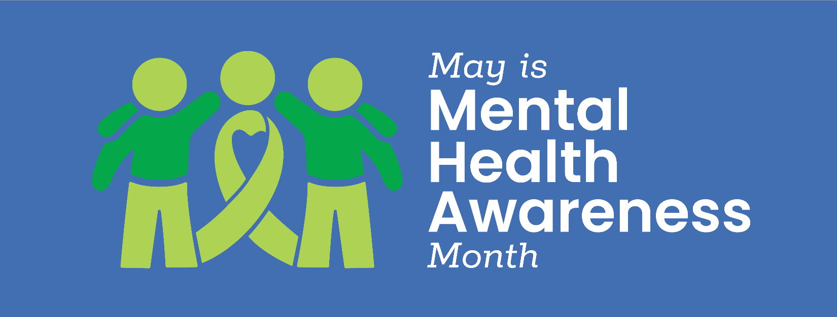
Dear Colleagues,

This May, in recognition of Mental Health Awareness Month, SFHSS is launching the Together in Well-Being: Mind, Heart, Body, Spirit campaign to support employee well-being.

Throughout the month, you will have the opportunity to explore simple strategies and resources to help nourish your mind, heart, body, and spirit. There will be plenty of activities to try something new or continue healthy habits that already support your well-being. This campaign encourages reflection, connection, movement, and curiosity to help you discover what works best for you.

We also invite you to participate in the Together in Well-Being Challenge by engaging in weekly activities designed to support each of the 4 Pillars:

Pillar 1: Reflect and Do – Pause, reflect, and take small actions to support your well-being
Pillar 2: Talk and Feel – Connect with others and check in on how you’re doing
Pillar 3: Move and Be – Incorporate movement and mindful awareness into your day
Pillar 4: Choose Your Own Adventure – Explore new or favorite activities that help you feel your best

Challenge details and how to participate:
- Starting May 4, you will receive weekly emails highlighting 1 of the 4 pillars
- Read the weekly “Together in Well-Being” emails for inspiration and a list of activities
- Explore the May events calendar and register for activities at sfhss.org/events
- Complete at least 3 activities each week
- Log your participation using the link provided in the weekly emails to be entered into raffle drawings

We encourage you to take part in a way that feels right for you. Even small steps can make a meaningful difference.

Warm regards,
[INSERT Signature]

