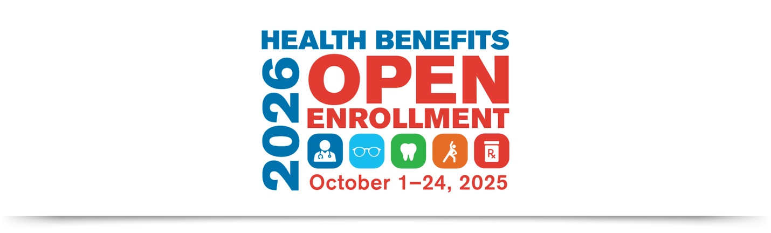

Subject: SFHSS Health Benefits Open Enrollment
Email Body:
The best benefits are the ones you actually use. If you haven’t had your annual wellness exam, dental cleaning, eye exam, or other preventive care this year, now is the perfect time to review your options. Take a fresh look at all the benefits available to you and see if another plan might meet your needs better.
The San Francisco Health Service System (SFHSS) invites you to explore your benefits and make any changes for the 2026 Plan Year during Open Enrollment, which runs from Wednesday, October 1, 2025, through Friday, October 24, 2025, at 5:00 p.m. PST.
Join us for Open Enrollment Benefits Fairs, webinars, or schedule a one-on-one consultation during your health plan vendor’s Office Hours. Full details will be available starting at 8:00 a.m. on Wednesday, October 1 at sfhss.org/oe2026.
