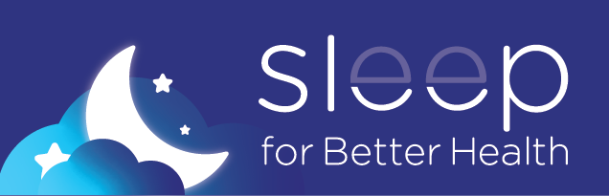
Sleep Well, Be Well
Sleep for Better Health. Our busy lives make it easy to take sleep for granted, but with the right amount of sleep, you can reduce stress, increase energy, and improve your overall well-being. The Sleep for Better Health campaign will help you understand the importance of getting healthy sleep, introduce programs and resources, and provide the tools to build a healthy sleep routine.
This month, you’ll receive emails with programs, resources, and activities to help your journey to get better sleep. Get started today and visit sfhss.org/sleep-campaign to learn more.
Need support? Sign up for a program and check out the resources below to help improve your sleep habits:
- Healthy Sleep Program: Join this 4-week program led by a Lifestyle Coach. Learn how bedtime habits and thinking patterns affect sleep, and how to change them.
  - Cohort 1: Meets Mondays, starts March 11 (5:30pm-6:30pm)
  - Cohort 2: Meets Tuesdays, starts March 12 (12pm-1pm)
- Healthy Sleep Coaching: Check in with a Lifestyle Coach to discuss and set goals to support good sleep hygiene. Schedule a 20-minute telephone appointment today.
  - Appointments available April 2, 3, 4, 9, 10 & 11 (10am-2pm)
- Tap Into your Health Plan Benefits: Explore well-being resources and programs that can help support your journey for better sleep.
- Employee Assistance Program: Your mental and emotional health can affect how well you sleep; reach out to EAP for support.
Additional Resources:
- SFHSS Events Calendar
- Tips That Can Help First Responders and Shift Workers Get Better Sleep
- CredibleMind Sleep Better Series
- HelpGuide Bedtime Meditation
Learn More at sfhss.org/sleep-campaign
Thank you,
[Add Champion Name(s)]

