Raise Awareness:
Promotional Communications

Department Email Templates —Customize it for your employees:

Email Template #1 - Encourage Employees to RECHARGE

Subject Line: Take Time To RECHARGE

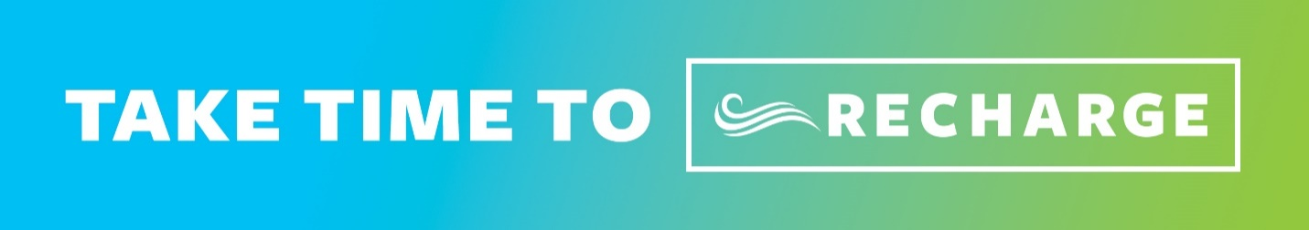

You spend your workday serving the City/City employees. To be the best at what we do and to feel your best every day, it is important take care of yourself. This may involve eating nutritious foods, being physically active, getting enough sleep, or taking time to be grateful. It can also be as simple as taking a minute to breathe or stretch.

One important way to take care of yourself at work is to take your breaks. These are opportunities to clear your mind which research shows may lead to greater productivity and creativity. Research shows additional benefits when breaks are spent on healthy activities such as deep breathing, stretching, moving, and eating nutritious foods.

I encourage each of you review the RECHARGE resources available through Better Every Day (the City’s well-being initiative). There are videos and handouts to teach you simple breathing and stretching routines to help you reset, relax, refresh, and RECHARGE.

Email Template #2 - Promote Onsite activities and environmental supports

Subject Line: Take Time To RECHARGE

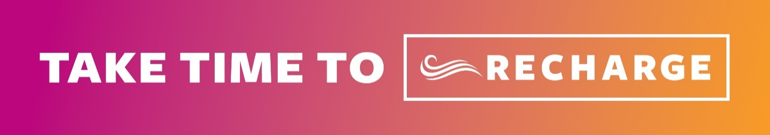

To help remind us all of the importance of taking a minute to breathe and stretch, not just today, but every day: List any of the opportunities your department has to encourage employees to RECHARGE
- You can find some of the printed RECHARGE resources in LOCATION.
- Attend…Details about any onsite activities
- We are encouraging all meeting leaders to include a 60-second breathing or stretching break in all meetings that are 60 minutes or longer
- Location will be dedicated for you to RECHARGE on your breaks
- We will be distributing educational resources to help you breathe and stretch
- We are having a RECHARGE Workstation contest (provide details)
- We wanted to remind you about the nearby group exercise classes you can attend on your lunch break
- Etc.
Thank you for all you do. Remember to reset, relax, refresh, and RECHARGE!

RECHARGE by sitting down somewhere comfortable and close your eyes. Take a few moments to breathe regularly, allowing your body to slow down. Focus on your inhale and exhale, try to have your mind wander. Do this for at least 1 minute.

____________________________________________________________

Department Newsletter/Employee Portal (RECHARGE Reminders):
Promote simple ways to RECHARGE

Newsletter Content #1

The power to manage stress is inside you. Learn to activate your natural relaxation response, so you can reduce stress hormones, slow heart rate, lower blood pressure, and release muscle tension. Increase your energy, focus, and productivity. Feel calmer, less stiff, and able to address stressful situations.

Find all the RECHARGE resources including the Breathing and Stretching videos at https://www.sfhss.org/well-being/stress-management any time of the year.

Newsletter Content #2

IMPROVE YOUR MOOD, IMPROVE YOUR PRODUCTIVITY.
Focus on how recharging can improve your mood and enhance your productivity. When you have an important or complex task to complete, take a minute to breathe or stretch before you begin.
The 4-County Belly Breath will help stimulate your body’s natural relaxation response:
Step 1: Inhale fully. Place your hands on your belly. Breathe in slowly through your nose to fill your lungs. Feel your abdomen expand like a balloon.
Step 2: Exhale fully. As you blow out, slowly release the air through your nose. Draw your belly button back toward your spine. Deflate the imaginary balloon.
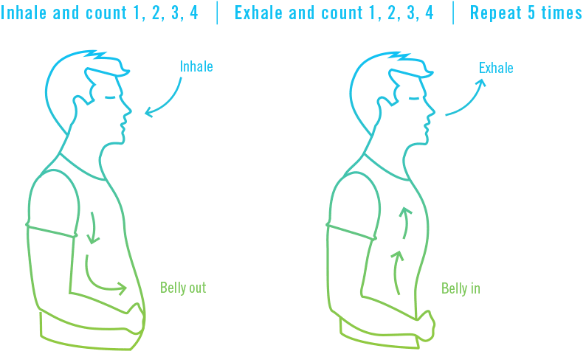
Use the time to clear your mind of distractions so that you can give all of your attention to the task at hand. You’ll be surprised how much more enjoyable the task can be when you put your mind and body in the right frame of mind.
Newsletter Content #3
Two of the simplest ways to manage stress and increase your focus and energy are by breathing and stretching. Both activities initiate the relaxation response which slows heart rate, lowers blood pressure, and reduces tension in your muscles. And you can do them anytime, anywhere.

Learn quick, easy breathing techniques and stretches that will help you:
- handle stressful situations
- increase your energy
- improve focus and productivity
- reduce stiffness
- feel calmer

Find stress management resources including the Breathing and Stretching videos at https://www.sfhss.org/well-being/stress-management any time of the year.
___________________________________________________________________

Highlight Monthly Tips: Mix and match or find your own tips

January
Create an environment at home or work that reminds you to reset, relax, refresh and RECHARGE.

February
Make it a point to relax every day. Do something that is relaxing and that you enjoy. Read a book, listen to music, meditate, do yoga or tai chi, or journal.

March
Take a minute to RECHARGE before an important task and increase your productivity.

April
Eat nutritious whole foods and enjoy your meals slowly. Exercise to release chemicals that make you feel better.

May
Breath to relax - If you're feeling overwhelmed or are coming out of a tense meeting and need to clear your head, a few minutes of deep breathing will restore balance.

June
Take breaks to help with focus and energy - Schedule breaks throughout the day to walk, stretch at your desk or do a breathing exercise.

July
Be active and get plenty of exercise to help to manage stress, aim for 30 minutes, 5 days a week.

August
Eat a balanced and healthy diet, choose whole and nutritious foods.

September
Listen to soothing sounds or music – nature sounds, or relaxing music is something that almost anybody can access and makes it an easy stress reduction tool.

October
Use the quiet time by yourself to check in.

November
Be thankful - There is something to be thankful for in every minute of every day. Make a list of everything great in your life.

December
Stay connected with the people that matter the most.

Use Logos and Images:
